Testing iperf

The results of the iperf bandwidth testing tool finger print engine were promising. The tests were conducted with the following topology:

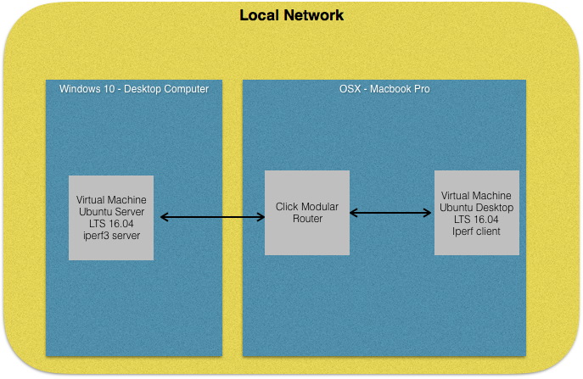

Multiple tests were run using a standard bandwidth shaping element in [Click], BandwidthRatedUnqueue(10000), limiting the rate to 10000 Bytes/s or 0.08Mb/s. These tests were to set the baseline to determine if traffic shaping was halted using the iperf finger printing engine. The following figure represents the results that were seen testing iperf against the click module BandwidthRatedUnqueue shaper. The results fluctuated with the first figure representing a lower average bound and the second figure representing the upper average bound.

Figure 1



Figure 2



Once the iperf fingerprinting module was put in place, the transfer rate showed a significant increase. Figure 3 represents the lower average bound while figure 4 represents the average upper bound.

Figure 3



Figure 4



The click router ran very inconsistently during the tests. More testing and further refining of the testing environment will be required to confirm accuracy. To further give traction to the results another test was run with the click router simply queuing and forwarding all packets. Figure 5 was the average of the results using simply a store and forward.



These results show that the iperf tool can be detected in real time. Once iperf was detected, the click module was able to allow the iperf test to reach similar speeds shown when a simple store and forward module was used.

Real time testing of the speedtest was unsuccessful. Due to the limitations of running the click module in user space, the test was not able to successful connect to its testing servers and run the speed test. This could be due to inefficiencies in our fingerprinting engine. The test could run while simply storing and forwarding packets, but did not connect once the fingerprinting engine was started. Figure 6 is the test results from running the click module of store and forward. To ensure that the issue lay with the fingerprinting engine running in user space in click, the module was run on the host OSX machine. The speedtest module then performed as expected meeting similar speed as seen in Figure 6. Although this breaks our testing environment, it does provide some hope that our fingerprint live test was successful. However, to further complicate the live test issue, the speedtest would not run while the bandwidthshaping module was running.



The alternative testing of using pcaps showed great promise for the fingerprinting engine. Using pcaps instead of live testing showed that the engine identified and stop shaping the speedtest traffic consistently. Five samples of two different tests were used. The first test ran only the speedtest.net testing tool. The second ran the tool while opening other websites to simulate traffic. The results were measured in the amount of packets that were shaped vs unshaped.

As you can see by the table, the fingerprint was able to detect in the pcaps when a speedtest occurred. Test case 1, 2, 5 in both test cases show the fingerprint to be very accurate. During test 3 and 4 in the speedtest with traffic, the test errored out. This error broke the fingerprinting. Although the live test did not produce results, the results in the offline test show that it may be possible to design a fingerprint that can identify the speedtest during a live run.

Fast.com was the most difficult to fingerprint and test. Unfortunately the live tests were inconclusive. Similar to speedtest.net we were unable to run the fast.com tests. Our current implementation of the fingerprint engine and knowledge of the click modular router will need to be improved upon. The fallback method of testing was used on fast.com and can be seen in the table.

As previously thought, Fast.com proved to be the most difficult to detect. The tool was only detected 5 times out of 15 tests. Even though the sample size for these tests are small, our tool has a 33% chance of detecting fast.com. Fast.com proved to be very stealthy.

Automated Testing Proceedure

To generate and test multiple pcaps, an automated testing scrip was created for each tool. The following is how each script generated the pcap files:

1. Run tcpdump
2. Start the tool **
3. Run any options in the tests, ie generate other traffic other than the tool
4. Stop and save tcpdump once test has finished
5. Repeat 5 times with different options

*Speedtest.com and Fast.com had to be initialized by hand because the tests were failing.

A second script was written to process each pcap file for the statistics:

1. The click module was run with each pcap file to filter into a shaped.pcap and unshaped.pcap
2. Run tshark to filter out all TCP conversations in the raw, shaped, and unshaped
3. A python script then built the tables** for these conversations adding important information from the tshark dump and resolving host names for analyzing if correct TCP streams were detected
4. The tables were aggregated and manually entered into an excel table to graph.

*All tables can be found in the form of <test>results<test_type>.txt